Market design

David Leitch

2024-08-08

# Energy only markets may not function well in a high VRE system

More and more questions are being asked about energy only markets and specifically whether spot prices will deliver the right price signals and whether private contracts will ensure that on average prices are appropriately set at the margin.

There are several lines of doubt about energy only markets for a wind and solar system. They are:

1. **Wind and solar producers don’t respond to price signals**. Or at least the signal is essentially binary. Since there are next to no marginal costs for producing wind or solar the only question is whether the price is positive or negative. If the price is positive (net of MLF) then the wind or solar producer wants to produce.
2. **Spot revenue may not provide a return to most generators**. When bulk energy production is dominated across the whole NEM by wind and solar there will likely be oversupply for large portions of the year. That’s because there has to be enough capacity available to produce the energy sufficient to charge all the required storage. The nature of renewable energy is that at times there will be a surplus of output beyond what the storage system can cope with. This is no different to rain, sometimes it floods, sometimes there is just too much rain. At those times wind and solar will earn nothing in the spot market as the oversupply will lead to a low spot price.
   1. Seasonality exacerbates this issue. It won’t ever be economic to build enough stationary storage to absorb all the Spring surplus and then keep it until late Autumn.
   2. You only have to look at prices at lunchtime or prices in Spring or the prices for wind producers in South Australia to see this effect already at work even though we are still at less than 40% VRE supply in the NEM overall.

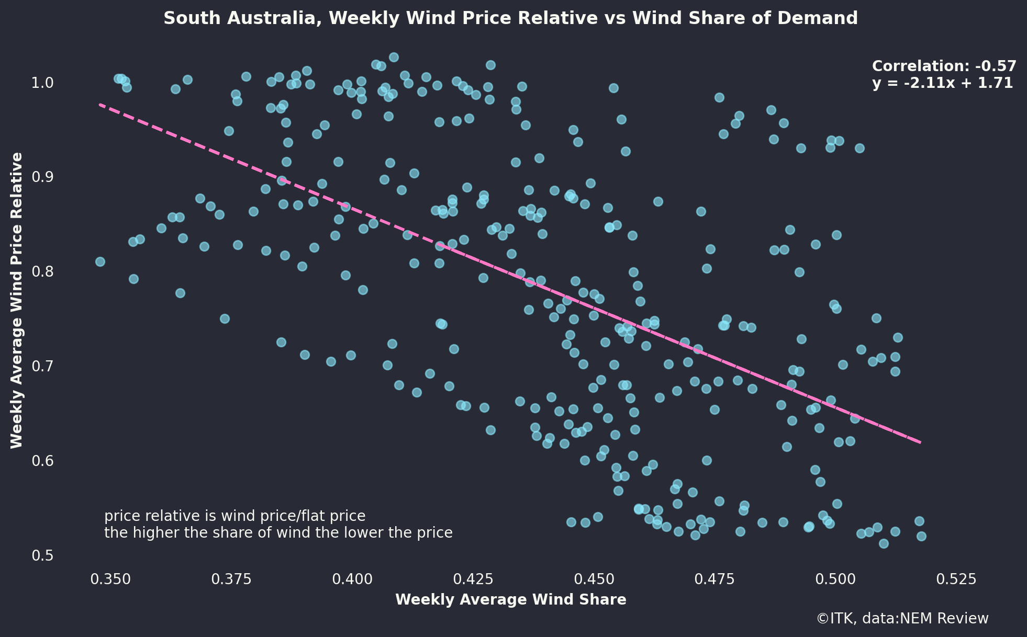

More supply, lower price

Counter points are:

* Spot prices are artificially depressed by must run thermal capacity that will eventually exit;
* More storage will produce more charging demand which will absorb the VRE excess production.
* EVs can provide a lot of storage, but equally have a high charging requirement. EVs aren’t going to be charging in Spring and then discharging in late Autumn.
* However to absorb all the excess requires more than an economic level of storage.

3 **When there are wind and solar droughts the spot price will be set by dispatchible power**, some combination of batteries/pumped hydro and gas/hydrogen. The dispatchible sector will have to have a clear view of opportunity cost because any extended VRE drought will make recharging storage difficult and tend to leave pricing at the mercy of gas/hydrogen. However the main point is that wind and solar producers wont get the high prices.

## Its now time to plan for a capacity driven market

The consensus plan to decarbonise the world, including Australia is “Electrify everything”

* Decarbonising Australia starts by decarbonising electricity and simultaneously electricity other energy consuming processes but principally transport and process heat.
* The ISP shows that a decarbonised electricity system where the energy very largely comes from wind and solar will be **reliable**. Never mind whether the cost inputs and timing are correct or not, the essential point for this discussion is that using PLEXOS modelling and additional studies the lights stay on.

Equally it is very likely that the ISP outputs in terms of fuel mix, and even in terms of transmission requirements do depend on the input assumptions, are calculated on the basis of Goverment policies of the day and will change as the inputs change. It was this caution that underlay “least regrets” concepts adopted in the “Finkel Report”. Nevertheless laws of nature and physics provide an overwhelming certainty to stakeholders that decarbonisation will remain a policy imperative until it is achieved and that no Goverment can do more than through sand in the gears of decarbonisation. In my opinion stakeholder conviction around the significance of climate change grows ever stronger, and is becoming more internalised in decision making as opposed to lip service.

There are lot of things that flow from a realisation that we will have a largely wind and solar powered Australia. Oversizing transmission links seems an obvious thing, blending in behind the meter and understanding the best way to organise distribution level and behind the meter storage is another but tied in with all of that is the role of markets.

## Planning and markets

I have been brought up to believe that markets do a better job of allocating resources than central planning.